**Assignment No.**

**Title:**

**Problem Statement:** Write a program using UDP Sockets to enable file transfer (Script, Text, Audio and Video one file each) between two machines. Demonstrate the packets captured traces using Wireshark Packet Analyzer Tool for peer to peer mode.

**Prerequisites: gcc/g++**

**Objectives:** To demonstrate the socket programming using UDP

**Theory:**

**UDP:**

UDP (User Datagram Protocol) is a communication protocol that offers a limited amount of service when messages are exchanged between computers in a network that uses the Internet Protocol (IP). UDP is an alternative to the Transmission Control Protocol (TCP) and, together with IP, is sometimes referred to as UDP/IP. Like the Transmission Control Protocol, UDP uses the Internet Protocol to actually get a data unit (called a datagram) from one computer to another. Unlike TCP, however, UDP does not provide the service of dividing a message into packets (datagrams) and reassembling it at the other end. Specifically, UDP doesn't provide sequencing of the packets that the data arrives in. This means that the application program that uses UDP must be able to make sure that the entire message has arrived and is in the right order. Network applications that want to save processing time because they have very small data units to exchange (and therefore very little message reassembling to do) may prefer UDP to TCP. The Trivial File Transfer Protocol (TFTP) uses UDP instead of TCP.

With a UDP socket a connection is NOT made, instead the sender just issues a message to its destination and hopes it gets there! The message uses a datagram of fixed length, often termed a record. Since there is no connection between client and server the client can send a datagram to one server and then immediately send a datagram to another server using the same socket UDP is a connectionless protocol.

Trivial File Transfer Protocol (TFTP) is a simple, lock-step, file transfer protocol which allows a client to get from or put a file onto a remote host. TFTP is a simple protocol for transferring files, implemented on top of the UDP/IP protocols using IANA registered port number 69. TFTP was designed to be small and easy to implement, and therefore it lacks most of the advanced features offered by more robust file transfer protocols. TFTP only reads and writes files from or to a remote server. It cannot list, delete, or rename files or directories and it has no provisions for user authentication. Today TFTP is generally only used on local area networks (LAN).

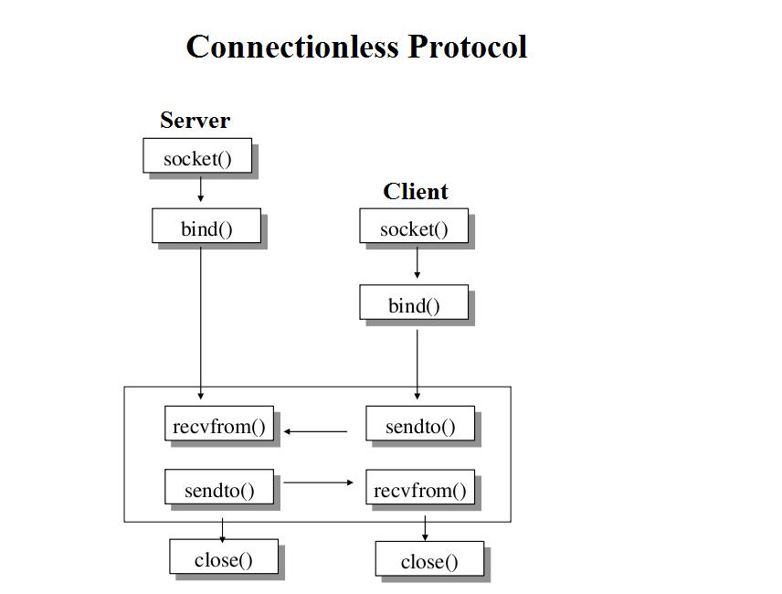

**Conclusion:** Thus we have successfully implemented the socket programming for UDP using C.